# Final Notebook

**Step-1**: Using Jupyter convert the notebook to HTML file.

**Step-2**: Copy the HTML file to the below location

GitHub\18_109A_Group14

**Step-3**: Open the HTML file in notepad++ and add the below code:

1.

Add the title as shown below:

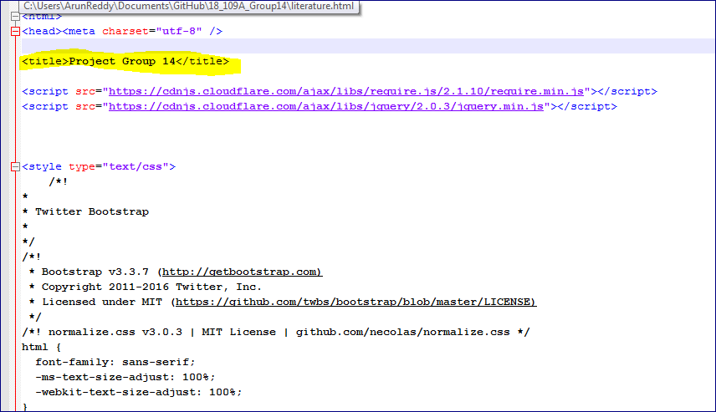

2.

Add the below highlighted script code. This code displays a button which will hide / show the code

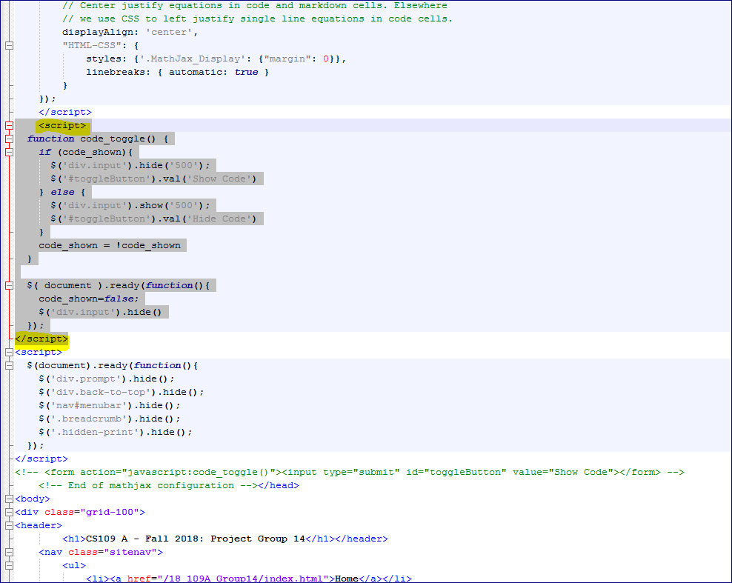

3.

Add the below highlighted script code. This code removes the cell prompts from HTML output

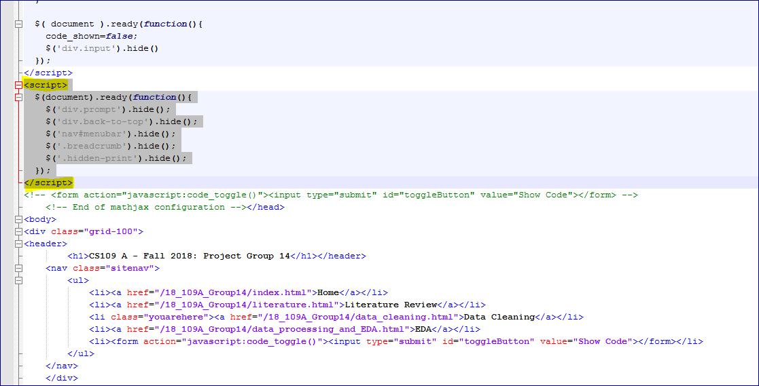

4.

Add the below code after <body> tag. Replace the FinalNotebook with exact name of the html file

<div class="grid-100">

<header>

<h1>CS109 A - Fall 2018: Project Group 14</h1></header>

<nav class="sitenav">

<ul>

<li><a href="/18_109A_Group14/index.html">Home</a></li>

<li><a href="/18_109A_Group14/literature.html">Literature Review</a></li>

<li><a href="/18_109A_Group14/data_cleaning.html">Data Cleaning</a></li>

<li><a href="/18_109A_Group14/data_processing_and_EDA.html">EDA</a></li>

<li class="youarehere"><a href="/18_109A_Group14/**FinalNotebook**.html">EDA</a></li>

<li><form action="javascript:code_toggle()"><input type="submit" id="toggleButton" value="Show Code"></form></li>

</ul>

</nav>

</div>

# Data_Cleaning.html

Step-1: Open the data_cleaning.html file and add the below yellow highlighted code. Replace the FinalNotebook with exact name of the html file

<nav class="sitenav">

<ul>

<li><a href="/18_109A_Group14/index.html">Home</a></li>

<li><a href="/18_109A_Group14/literature.html">Literature Review</a></li>

<li class="youarehere"><a href="/18_109A_Group14/data_cleaning.html">Data Cleaning</a></li>

<li><a href="/18_109A_Group14/data_processing_and_EDA.html">EDA</a></li>

<li><a href="/18_109A_Group14/FinalNotebook.html">EDA</a></li>

<li><form action="javascript:code_toggle()"><input type="submit" id="toggleButton" value="Show Code"></form></li>

</ul>

</nav>

# Data_Processing_and_EDA.html

Step-1: Open the data_processing_and_eda.html file and add the below yellow highlighted code. Replace the FinalNotebook with exact name of the html file

<nav class="sitenav">

<ul>

<li><a href="/18_109A_Group14/index.html">Home</a></li>

<li><a href="/18_109A_Group14/literature.html">Literature Review</a></li>

<li><a href="/18_109A_Group14/data_cleaning.html">Data Cleaning</a></li>

<li class="youarehere"><a href="/18_109A_Group14/data_processing_and_EDA.html">EDA</a></li>

<li><a href="/18_109A_Group14/FinalNotebook.html">EDA</a></li>

<li><form action="javascript:code_toggle()"><input type="submit" id="toggleButton" value="Show Code"></form></li>

</ul>

</nav>

# Literature.html

Step-1: Open the literature.html file and add the below yellow highlighted code. Replace the FinalNotebook with exact name of the html file

<nav class="sitenav">

<ul>

<li><a href="/18_109A_Group14/index.html">Home</a></li>

<li class="youarehere"><a href="/18_109A_Group14/literature.html">Literature Review</a></li>

<li><a href="/18_109A_Group14/data_cleaning.html">Data Cleaning</a></li>

<li><a href="/18_109A_Group14/data_processing_and_EDA.html">EDA</a></li>

<li><a href="/18_109A_Group14/FinalNotebook.html">EDA</a></li>

<li><form action="javascript:code_toggle()"><input type="submit" id="toggleButton" value="Show Code"></form></li>

</ul>

</nav>

# Index.html

Step-1: Open the index.html file and add the below yellow highlighted code. Replace the FinalNotebook with exact name of the html file

<nav class="sitenav">

<ul>

<li class="youarehere"><a href="/18_109A_Group14/index.html">Home</a></li>

<li><a href="/18_109A_Group14/literature.html">Literature Review</a></li>

<li><a href="/18_109A_Group14/data_cleaning.html">Data Cleaning</a></li>

<li><a href="/18_109A_Group14/data_processing_and_EDA.html">EDA</a></li>

<li><a href="/18_109A_Group14/FinalNotebook.html">EDA</a></li>

<li><form action="javascript:code_toggle()"><input type="submit" id="toggleButton" value="Show Code"></form></li>

</ul>

</nav>